AIML SESSION 04 ASSIGNMENT SUBMISSION

Name of student: Vaibhav Vijay Kate
Domain/subject name: AIML (Artificial Intelligence & Machine Learning)
College and Branch name: Government Polytechnic College Washim (IF)

Task 1. Lambda Function
Write a lambda function named square that takes a number x and returns its square. Call the lambda function with input from the user and print the result. Also write the same logic using a normal def function and compare both in comments.
Program Code:
# Lambda Function

square = lambda x: x * x
number = float(input("Enter a any number: "))

print("Square using lambda:", square(number))

# Normal Function

def square_def(x):
return x * x

print("Square using normal function:", square_def(number))

OUTPUT Screenshot:
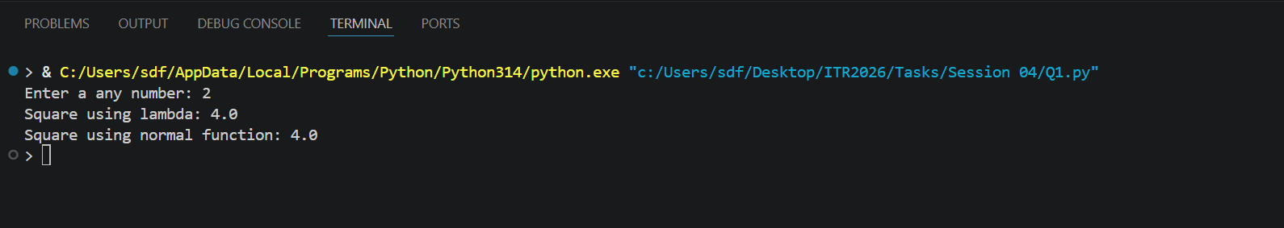
Task 2: Lambda with Multiple Arguments
Create a lambda function add_three(a, b, c) that returns the sum of three numbers. Take three numbers as input from the user and print their sum using this lambda function.
Program Code:
add_three = lambda a, b, c: a + b + c

a = float(input("Enter first number: "))
b = float(input("Enter second number: "))
c = float(input("Enter third number: "))

print("Sum =", add_three(a, b, c))

OUTPUT Screenshot:
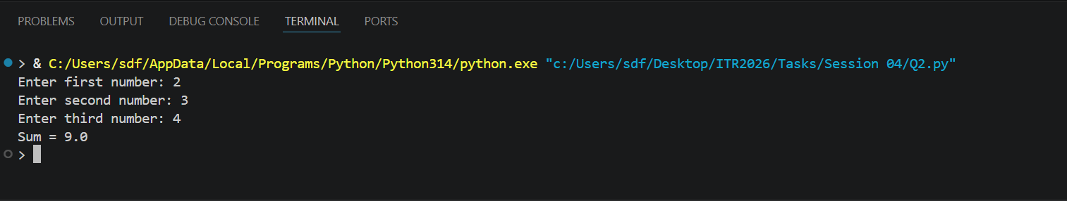
Task 3: . For Loop Revision
Write a program using a for loop and range() to: a) Print all numbers from 1 to 25. b) Print the sum of all numbers from 1 to 20. c) Print the table of 5 5 1 to 5 10. Add comments explaining when to use for loop.
Program Code:
# For loop is used for repeating a tasks a specific number of times. It is used when the number of iterations is known beforehand. The syntax of a for loop in Python is as follows:

print("Numbers from 1 to 25:")
for i in range(1, 26):
print(i)
tot = 0

for i in range(1, 21):
tot += i

print("Sum of numbers from 1 to 20 =", tot)
print("Table of 5:")

for i in range(1, 11):
print(f"5 x {i} = {5 * i}")

OUTPUT Screenshot: 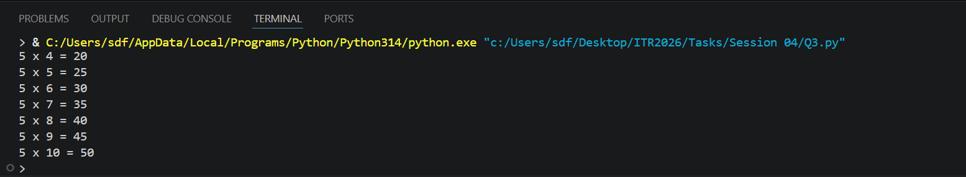
Task 4: . While Loop Revision
Write a program using a while loop that: Repeatedly asks the user to enter a positive number. Keeps adding the numbers to a running total. Stops when the user enters 0 or a negative number. Finally prints the total sum.
Program Code:
# Initialize sum variable
total = 0

# Loop until user enters non-positive number
while True:
# Get number from user
value = float(input("Enter a positive number (0 or negative to stop): "))

# Exit loop if number is not positive
if value <= 0:
break

# Add to running total
total += value

# Display final sum
print("Total Sum =", total)

OUTPUT Screenshot: 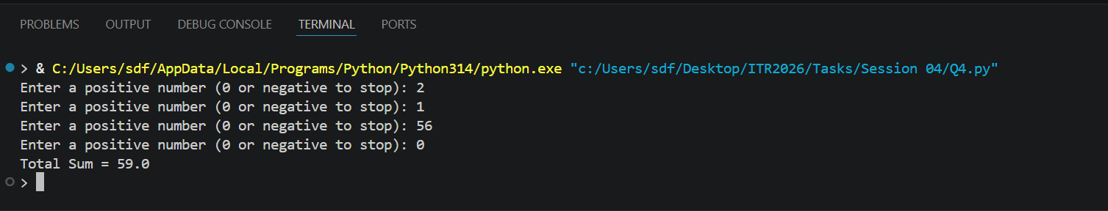
Task 5: Math Module
Write a program that imports the math module and does the following: Takes a number as input. Prints its square root using math.sqrt(). Prints its factorial using math.factorial() (for positive integers only). Prints the ceiling and floor value using math.ceil() and math.floor(). Add comments about the usefulness of the math module.
Program Code:
import math

# Get numeric input from user
value = float(input("Enter a number: "))

# Calculate square root (only for non-negative values)
if value < 0:
print("Square Root = Not defined for negative numbers")
else:
print("Square Root =", math.sqrt(value))

# Calculate and display ceiling and floor values
print("Ceiling Value =", math.ceil(value))
print("Floor Value =", math.floor(value))

# Calculate factorial (only for non-negative integers)
if value >= 0 and value.is_integer():
print("Factorial =", math.factorial(int(value)))
else:
print("Factorial can only be calculated for non-negative integers.")

OUTPUT Screenshot:
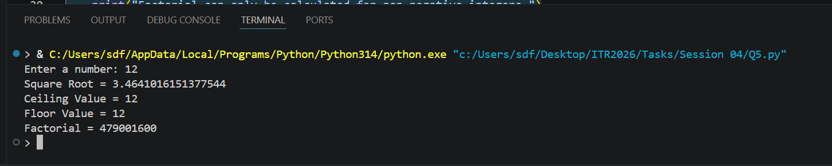
Task 6: Random Module
Write a program using the random module that: Generates and prints 5 random integers between 1 and 100. Generates and prints one random number between 50 and 150. Prints a random floating point number between 0 and 1. Use different functions from the random module.
Program Code:
import random

print("five random integers:")

for i in range(5):
print(random.randint(1, 100))
print("Random Number between 50 and 150:", random.randint(50, 150))
print("Random Floating Number:", random.random())

OUTPUT Screenshot:
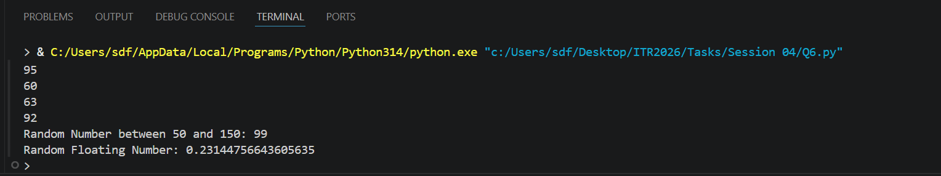
Task 7: Import Methods
Demonstrate different ways of importing modules: Import the entire math module using import math and use math.pow(2, 4). Import only sqrt from math using from math import sqrt. Import math with an alias as m and use m.factorial(5. Print the results with clear messages.
Program Code:
# Method 1
import math
print("Factorial of 5 =", math.factorial(5))
print("2^4 using math.pow =", math.pow(2, 4))

# Method 2
from math import sqrt
print("Square Root of 25 =", sqrt(25))

# Method 3
import math as m
print("Factorial of 5 =", m.factorial(5))

OUTPUT Screenshot:
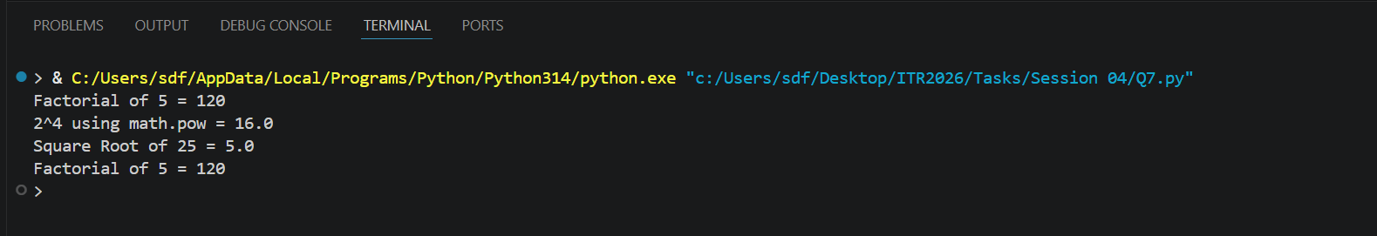
Task 8: Custom Module
Create a custom module file named mymodule.py that contains: A function greet(name) that prints "Hello [name], Welcome to Python Class!" A function calculate_power(base, exp) that returns base raised to exponent. Then write a main program that imports this module and uses both functions.
Program Code:
# Main program that imports and uses the custom module
import mymodule

# Using greet() function
mymodule.greet("Vaibhav")

# Using calculate_power() function
result = mymodule.calculate_power(2, 5)
print("2 raised to the power 5 =", result)

OUTPUT Screenshot:
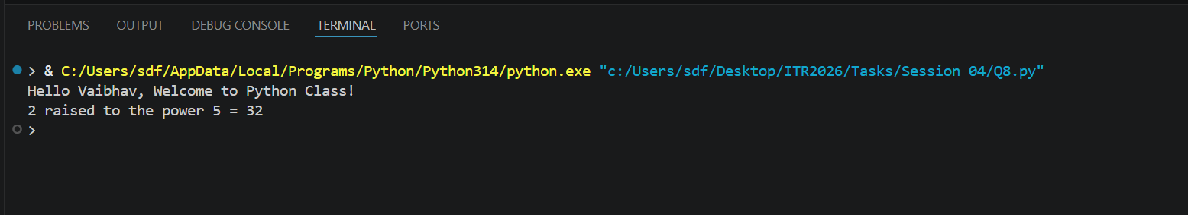
Task 9: (name == "main")
Write a program that: a) Creates a small function and demonstrates the use of if __name__ == "__main__": so that some code runs only when the file is executed directly.
Program Code:
def greet():
print("Welcome to Python Programming!")

if __name__ == "__main__":
print("This file is being run directly.")
greet()

OUTPUT Screenshot: 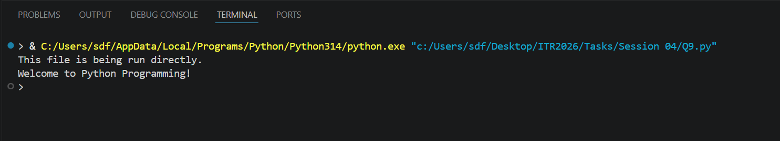

Task 10: Mini Project –
Combined Concepts) Create a Simple Math Utility Program using functions, lambda, loops and modules: Write the following: A lambda function to calculate square of a number. A normal function using math module to calculate power. Use a while loop to repeatedly ask the user for a number and choice Square / Power / Random Number). Use random module to generate a random number when chosen. Continue until the user chooses to exit. Use proper functions and comments. 3 Session 04 (AIML) - Assignment Questions
Program Code:
# Math Utility Program - Combined Concepts
import math
import random

# Lambda function for square
square = lambda x: x ** 2

# Function for power calculation
def calculate_power(base, exp):
return math.pow(base, exp)

# Function for random number
def generate_random():
return random.randint(1, 100)

# Main program
while True:
print("\n1. Square 2. Power 3. Random 4. Exit")
choice = input("Choice: ")

if choice == '1':
num = float(input("Enter number: "))
print(f"Square = {square(num)}")
elif choice == '2':
base = float(input("Base: "))
exp = float(input("Exponent: "))
print(f"Power = {calculate_power(base, exp)}")
elif choice == '3':
print(f"Random = {generate_random()}")
elif choice == '4':
print("Goodbye!")
break
else:
print("Invalid choice!")

OUTPUT Screenshot:
